# Technical Design Document for User Approvals App

# Overview

The solution is designed to facilitate smooth interactions between various components, including Power Automate flows and Microsoft Teams integrations. The Single Approver Flow and Complex Sequential Approval flows exemplify the automation capabilities, enhancing the user experience by simplifying complex processes. Implementation complexities arise from ensuring seamless connectivity with external services and managing data security.

## Solution Details

|  |  |
| --- | --- |
| **Property** | **Value** |
| **Solution Name** | User Approvals App |
| **Unique Name** | PowerAppsApprovals |
| **Description** | No description provided. |
| **Solution Type** | Unmanaged |
| **Version** | 1.0.0.0 |

## Pre-requisites

### Connection References

|  |  |
| --- | --- |
| **Display Name** | **Logical Name** |
| Approvals PowerAppsApprovals-b9125 | mscsu_sharedapprovals_b9125 |
| Approvals PowerAppsApprovals-d2f4e | mscsu_sharedapprovals_d2f4e |
| Microsoft Dataverse PowerAppsApprovals-49259 | mscsu_sharedcommondataserviceforapps_49259 |
| Microsoft Teams PowerAppsApprovals-6bb42 | mscsu_sharedteams_6bb42 |
| Microsoft Teams PowerAppsApprovals-a98f2 | mscsu_sharedteams_a98f2 |

# User Experience and Automations

## Canvas Apps / Custom Pages

### User Approvals App:

**Description:** The application is designed to serve as a comprehensive platform for users, providing a centralized interface that facilitates seamless navigation and access to various functionalities.

#### Screens

##### Dashboard

**Description:** The Dashboard Screen serves as the central hub of the application, guiding users through various functionalities and ensuring a seamless navigation experience. It plays a crucial role in organizing content and features, allowing users to efficiently access the tools they need. It allows users to quickly make a request,

##### Request Templates

**Description:** The Request Templates Screen allows users to quickly fill in a simple form to quickly create a simple request.

##### Request Templates

**Description:** The Multi Approval Request screen is where users can come to create a new Dynamic approval request. This allows users to create a approval request where they can decide on the number of stages.

## Power Automate

|  |  |  |  |
| --- | --- | --- | --- |
| **Flow Name** | **Description** | **Triggers** | **Actions** |
| Single Approver Flow | Automates the approval process by sending approval requests and notifications. | * Manual trigger via PowerAppV2 | * Start an approval |
| Complex Sequential Approval | Automates the sequential approval process, including retrieving a row by ID, starting and waiting for an approval, and updating the row based on decisions taken. | * manual | * Get a row by ID * Start and wait for an approval * Compose * Condition * Update a row |

## Tables

|  |  |  |
| --- | --- | --- |
| **Table Name** | **Description** | **Fields** |
| User Approval Requests | This table contains records of approval requests | * crf16_approvalhistory * crf16_approvers * crf16_daysalive * crf16_decisionstaken * crf16_enddate * mscsu_approval_status * mscsu_approvalid * mscsu_approvaltitle * mscsu_assignedto * mscsu_attachment * mscsu_cancelledreason * mscsu_currentstage * mscsu_details * mscsu_itemlink * mscsu_itemlinkdescription * mscsu_remindercounter * mscsu_requestor * mscsu_requestoremail |
| Approval Template | This table contains records of approval templates. | * mscsu_approvaltemplateid * mscsu_approvaltype * mscsu_description * mscsu_isactive * mscsu_noofinputs * mscsu_templatename |

## Entity Relationship Diagram

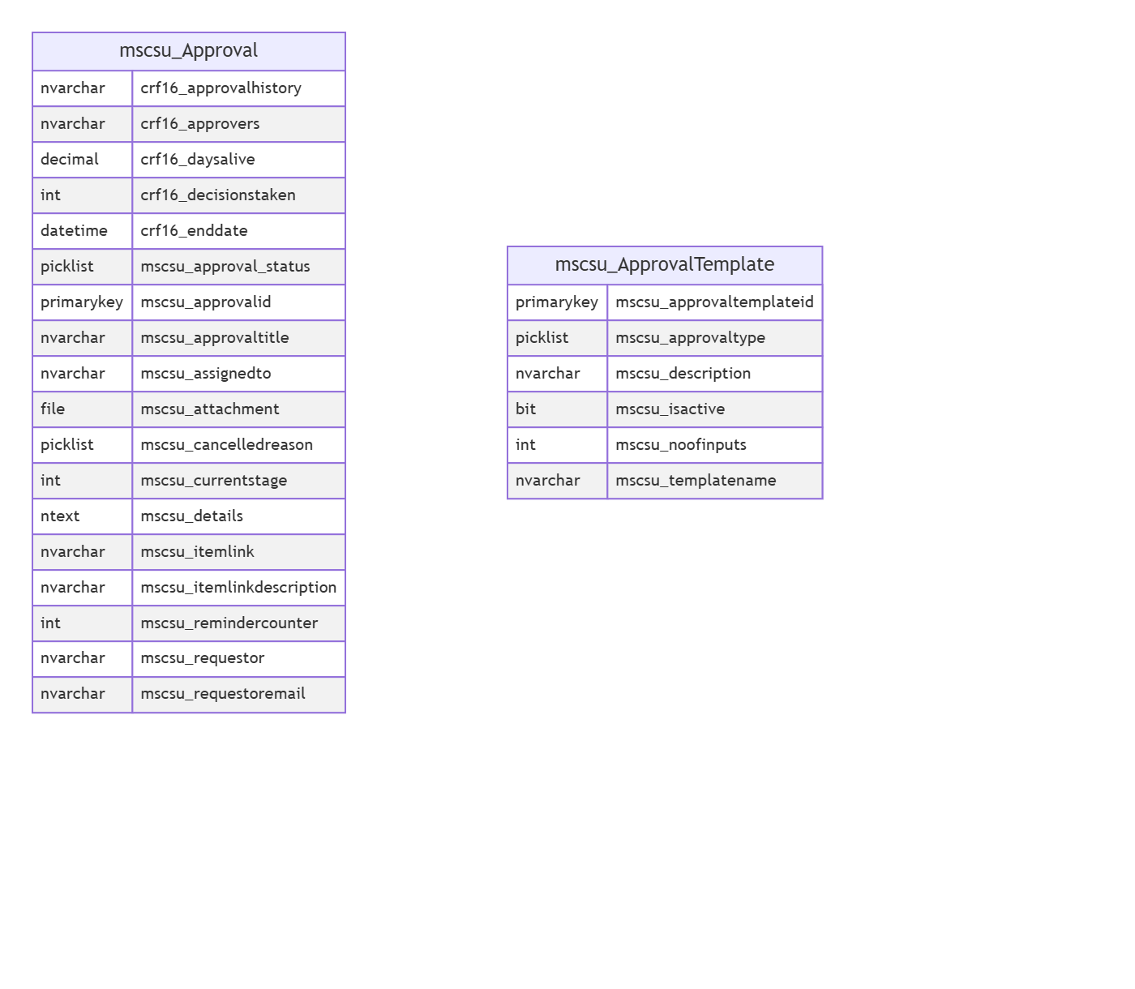

# Summary

The User Approvals App (Version 1.0.0.0) is designed to streamline the approval process within organizations. It addresses the business problem of inefficient approval workflows by providing a centralized platform for managing user approvals. Key technical capabilities include automated approval notifications, integration with Microsoft Teams, and connection to Microsoft Dataverse. End-users benefit from enhanced productivity through a user-friendly interface that simplifies task management. The solution also relies on essential integrations with Microsoft services, ensuring a seamless experience across platforms.